# **Build, Test and Use Straight-Through and Cross-Over UTP Cable**

**LAB # 03**



**Fall 2024**

Submitted by: **Mohsin Sajjad**

Registration No: **22pwsce2149**

Class Section: **A**

“On my honor, as student of University of Engineering and Technology, I have neither given nor received unauthorized assistance on this academic work.”



Student Signature: ______________

Submitted to:

**Dr. Yasir Saleem Afridi**

Month Day, Year (26 02, 2025)

Department of Computer Systems Engineering

University of Engineering and Technology, Peshawar

**CSE 303L: Data Communication and Computer Networks**

|  |  |  |  |  |
| --- | --- | --- | --- | --- |
| **Demonstration of Concepts** | **Poor (Does not meet expectation (1))**  The student failed to demonstrate a clear understanding of the assignment concepts | **Fair (Meet Expectation (2-3))**  The student demonstrated a clear understanding of some of the assignment concepts | **Good (Exceeds Expectation (4-5)**  The student demonstrated a clear understanding of the assignment concepts | **Score**  **30%** |
| **Accuracy** | The student mis-configured enough network settings that the lab computer couldn't function properly on the network | The student configured enough network settings that the lab computer partially functioned on the network | The student configured the network settings that the lab computer fully functioned on the network | **30%** |
| **Following Directions** | The student clearly failed to follow the verbal and written instructions to successfully complete the lab | The student failed to follow the some of the verbal and written instructions to successfully complete all requirements of the lab | The student followed the verbal and written instructions to successfully complete requirements of the lab | **20%** |
| **Time Utilization** | The student failed to complete even part of the lab in the allotted amount of time | The student failed to complete the entire lab in the allotted amount of time | The student completed the lab in its entirety in the al | **20%** |

**Credit Hours: 1**

## OBJECTIVES OF THE LAB

**----------------------------------------------------------------------------------------------------**

In this lab, we will cover the following:

* Introduction to Transmission Media
* Build a Category 6 (CAT 6) Straight-Through Ethernet network cable
* Build a Category 6 (CAT 6) Cross-Over Ethernet network cable
* Test both cables for good connection using Cable Tester
* Connecting Computers via Switch using Straight Through Cable and Connecting two computers directly via Cross Over Cable

**----------------------------------------------------------------------------------------------------**

## TRANSMISSION MEDIA

The transmission media is nothing but the physical media over which communication takes place in computer networks. The transmission of data over transmission media may be unguided (wireless) or guided (wired).

### WIRELESS

Wireless transmission is a form of unguided media. Wireless communication involves no physical link established between two or more devices, communicating wirelessly. Wireless signals are spread over in the air and are received and interpreted by appropriate antennas.

When an antenna is attached to electrical circuit of a computer or wireless device, it converts the digital data into wireless signals and spread all over within its frequency range. The receptor on the other end receives these signals and converts them back to digital data.

### WIRED

In wired communication a physical link is established between two devices. The link may be of different types.

#### WAVE GUIDE

A waveguide is a structure that guides waves, such as [electromagnetic waves](http://en.wikipedia.org/wiki/Electromagnetic_wave) or [sound](http://en.wikipedia.org/wiki/Sound) waves. There are different types of waveguides for each type of wave. The original and most common meaning is a hollow conductive metal pipe used to carry high frequency [radio waves](http://en.wikipedia.org/wiki/Radio_wave), particularly [microwaves](http://en.wikipedia.org/wiki/Microwave).

The geometry of a waveguide reflects its function. Slab waveguides confine energy to travel only in one dimension, fiber or channel waveguides for two dimensions. The frequency of the transmitted wave also dictates the shape of a waveguide: an [optical fiber](http://en.wikipedia.org/wiki/Optical_fiber) guiding high-[frequency](http://en.wikipedia.org/wiki/Frequency) [light](http://en.wikipedia.org/wiki/Light) will not guide [microwaves](http://en.wikipedia.org/wiki/Microwaves) of a much lower frequency. As a [rule of thumb](http://en.wikipedia.org/wiki/Rule_of_thumb), the width of a waveguide needs to be of the same [order of magnitude](http://en.wikipedia.org/wiki/Order_of_magnitude) as the [wavelength](http://en.wikipedia.org/wiki/Wavelength) of the guided wave.

Some naturally occurring structures can also act as waveguides. The [SOFAR channel](http://en.wikipedia.org/wiki/SOFAR_channel) layer in the ocean can guide the sound of [whale song](http://en.wikipedia.org/wiki/Whale_sound) across enormous distances.

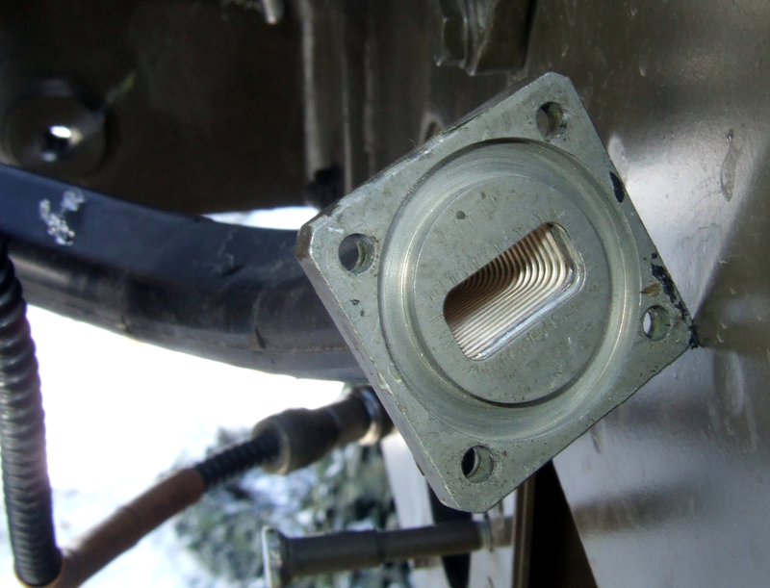

1. **(b)**

**Figure 3.1. (a) A section of flexible waveguide with a** [**pressurizable flange**](http://en.wikipedia.org/wiki/Waveguide_flange)**. (b) Electric field inside an x-band hollow metal waveguide.**

#### CABLE

Alternatively referred to as a cord, connector or plug, a cable is one or more [wires](http://www.computerhope.com/jargon/w/wire.htm) covered in a plastic covering that [connects](http://www.computerhope.com/jargon/c/connect.htm) a [computer](http://www.computerhope.com/jargon/c/computer.htm) to a power source or other device.

Networking cables are used to connect one network device to other network devices or to connect two or more computers to share [printer](http://en.wikipedia.org/wiki/Printer_%28computing%29), [scanner](http://en.wikipedia.org/wiki/Image_scanner) etc. Different types of network cables like [Coaxial cable](http://en.wikipedia.org/wiki/Coaxial_cable), [Optical fiber cable](http://en.wikipedia.org/wiki/Optical_fiber_cable), [Twisted Pair](http://en.wikipedia.org/wiki/Twisted_Pair) cables are used depending on the network's [topology](http://en.wikipedia.org/wiki/Network_topology), [protocol](http://en.wikipedia.org/wiki/Network_Protocols) and size. The devices can be separated by a few meters (e.g. via [Ethernet](http://en.wikipedia.org/wiki/Ethernet)) or nearly unlimited distances (e.g. via the interconnections of the [Internet](http://en.wikipedia.org/wiki/Internet)).

##### COAXIAL CABLE

Coaxial lines confine the electromagnetic wave to area inside the cable, between the center conductor and the shield. The transmission of energy in the line occurs totally through the dielectric inside the cable between the conductors. Coaxial lines can therefore be bent and twisted (subject to limits) without negative effects, and they can be strapped to conductive supports without inducing unwanted currents in them and though.

The most common use for coaxial cables is for television and other signals with bandwidth of multiple megahertz. Although in most homes coaxial cables have been installed for transmission of [TV](http://en.wikipedia.org/wiki/TV) signals, new technologies (such as the [ITU-T](http://en.wikipedia.org/wiki/ITU-T) [G.hn](http://en.wikipedia.org/wiki/G.hn) standard) open the possibility of using home coaxial cable for high-speed [home networking](http://en.wikipedia.org/wiki/Home_network) applications ([Ethernet over coax](http://en.wikipedia.org/wiki/Ethernet_over_coax)).

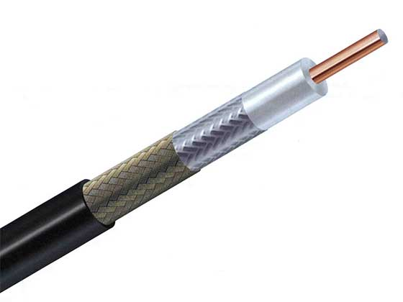

**Figure 3.2. Coaxial Cable**

##### TWISTED PAIR CABLE

A cable made by intertwining two separate insulated wires. There are two twisted pair types: shielded and unshielded. A [Shielded Twisted Pair (STP)](http://www.computerhope.com/jargon/s/stpcable.htm) has a fine wire mesh surrounding the wires to protect the transmission; an [Unshielded Twisted Pair (UTP)](http://www.computerhope.com/jargon/u/utpcable.htm) do not. The use of two wires twisted together helps to reduce [crosstalk](http://www.webopedia.com/TERM/C/crosstalk.html) and electromagnetic induction. While twisted-pair cable is used by older telephone [networks](http://www.webopedia.com/TERM/N/network.html) and is the least expensive type of [local-area network (LAN)](http://www.webopedia.com/TERM/L/local_area_network_LAN.html) cable, most networks contain some twisted-pair cabling at some point along the network.

e.g. [CAT2](http://www.computerhope.com/jargon/c/cat2.htm), [CAT3](http://www.computerhope.com/jargon/c/cat3.htm), [CAT4](http://www.computerhope.com/jargon/c/cat4.htm), [CAT5](http://www.computerhope.com/jargon/c/cat5.htm), [CAT5e](http://www.computerhope.com/jargon/c/cat5.htm), [CAT6](http://www.computerhope.com/jargon/c/cat6.htm), [CAT7](http://www.computerhope.com/jargon/c/cat7.htm).

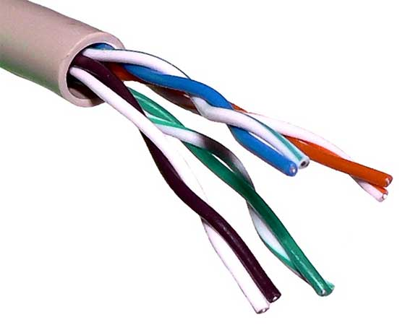

**Figure 3.3. CAT5 Twisted pair cable**

**Q. Write note on** [CAT2](http://www.computerhope.com/jargon/c/cat2.htm), [CAT3](http://www.computerhope.com/jargon/c/cat3.htm), [CAT4](http://www.computerhope.com/jargon/c/cat4.htm), [CAT5](http://www.computerhope.com/jargon/c/cat5.htm), [CAT5e](http://www.computerhope.com/jargon/c/cat5.htm), [CAT6](http://www.computerhope.com/jargon/c/cat6.htm), [CAT7](http://www.computerhope.com/jargon/c/cat7.htm).

##### FIBER OPTICS

Fiber Optic works on the properties of light. When light ray hits at critical angle it tends to refracts at 90 degree. This property has been used in fiber optic. The core of fiber optic cable is made of high quality glass or plastic. From one end of it light is emitted, it travels through it and at the other end light detector detects light stream and converts it to electric data.

Fiber Optic provides the highest mode of speed. It comes in two modes, one is single mode fiber and second is multimode fiber. Single mode fiber can carry a single ray of light whereas multimode is capable of carrying multiple beams of light.

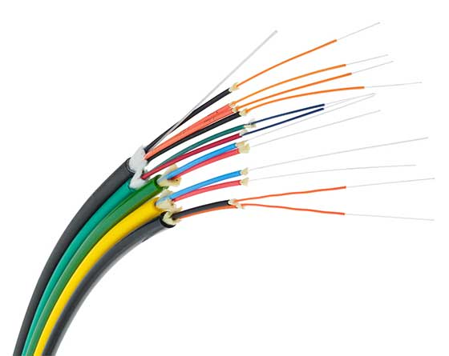

**Figure 3.4. Fiber optic**

Fiber Optic also comes in unidirectional and bidirectional capabilities. To connect and access fiber optic special type of connectors are used. These can be Subscriber Channel (SC), Straight Tip (ST), or MT-RJ.

## STRAIGHT-THROUGH CABLE

A straight-through network cable is just what the name suggests, a cable that passes data straight through from one end to another end. These cables are used for a variety of connections, for instance, connecting a computer to a hub or switch, connecting a computer to a cable/ISDN/DSL modem, and linking switches and hubs together. One such cable connection is shown in Figure 2.1.



**Figure 3.5. Straight-through Cable**

Typically the ports on a hub are MDIX ports that allow the machine at the other end to utilize its MDI Port without the need for a crossover cable. Through these ports, hub automatically performs the crossover functions, which are required to properly align the cables with each other. When no hub or switch is used, cable itself must physically perform these crossover functions.

**About Cabling**

The two most common UTP (Unshielded Twisted-Pair) network standards are the 100 Mbps (100BASE-T Ethernet) and the 1000 Mbps (1000BASE-TX Fast Ethernet). In order for a cable to properly support 100 Mbps transfers, Category 5 (or CAT 5) twisted pair cable must be used. Other types of cabling include Category 3 that supports data rates up to 16 Mbps, and Category 1 that only supports data rates up to 1Mbps.

**Tools Required**

The tools required to do this lab are:

* CAT 6 network cable
* RJ-45 Connectors
* Cable Cutter
* Crimping tool, &
* Cable tester.



**Figure 3.6. Tools Required for Cabling**

**Procedure**

Well, the wire has two sides. Let’s call one side … Side A and the other side … Side B. Do the following steps with Side A of the wire.

1. Remove the plastic cover from the cable up to two inches. You will see 4 twisted pairs (total 8 wires). In each twisted pair, one wire will be colored and the other will be white. For example, one will be Green and the other will be White having Green marks. The latter is called Green-White. Similarly there will be Brown wire twisted with Brown-White, Blue wire twisted with Blue-White, Orange twisted with Orange-White. This can be seen in Figure 2.3.



**Figure 3.7. Cable Pairs**

1. Untwist the wires and make them smooth (don’t remove the plastic covers from the metal wires).
2. Arrange the wires in the order shown below. The order is important since there is a wiring standard defined by the Telecommunications Industry Association (TIA) [http://www.tiaonline.org].
3. It's called the EIA/TIA-568 Commercial Building Telecommunications Wiring Standard, and you can find more information on it here: https://en.wikipedia.org/wiki/TIA/EIA-568
4. Cut the wires in straight fashion and insert in the RJ-45 Jack.
5. Using the Crimping tool, punch it properly. Perform Step 1-5 for Side B.

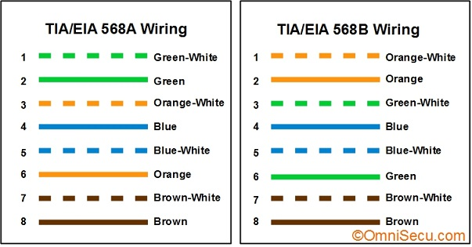

## CROSS-OVER CABLE

A cross-over network cable is used to connect two computers directly. It is also used when you connect two hubs/Switches with a normal port on both hubs/Switches. (In other words, the cross cable is used relatively in a rare case.). It is used to connect similar devices.



**Figure 3.8. Cross-Over Cable**

**Tools Required**

Same as used for making Straight-Through Cable.

**Procedure**

**Side A**

Perform Steps 1-5 mentioned above for making straight-through cable (EIA/TIA 568A standard)

**Side B**

Arrange the wires using EIA/TIA 568B standard And punch it properly.

## TESTING CABLES

Once both cables are ready, test it to make sure it works by means of a cable tester. Insert the two ends of the cable into the jacks on the tester and watch the lights. If they all light up, wire has a good connection and ready to use.

### CABLE TESTER

A cable tester is a device that is used to test the strength and connectivity of a particular type of cable or other wired assemblies. There are a number of different types of cable testers, each able to test a specific type of cable or wire (some may be able to test different types of cables or wires). The cable tester can test whether a cable or wire is set up properly, connected to the appropriate source points, and if the communication strength between the source and destination is strong enough to serve its intended purpose. The picture is an example of a cable tester from TRENDnet.

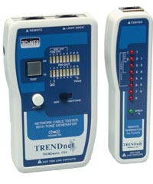

**Figure 3.9. TRENDnet Cable tester**

## NETWORKING DEVICES

### HUB

When referring to a [network](http://www.computerhope.com/jargon/n/network.htm), a hub is the most basic networking [device](http://www.computerhope.com/jargon/d/device.htm) that connects multiple computers or other network devices together. Unlike a network [switch](http://www.computerhope.com/jargon/s/switch.htm) or [router](http://www.computerhope.com/jargon/r/router.htm), a network hub has no routing tables or intelligence on where to send information and [broadcasts](http://www.computerhope.com/jargon/b/broadcas.htm) all network data across each connection. Most hubs can detect basic network errors such as collisions, but having all information broadcast to multiple ports can be a security risk and cause bottlenecks. In the past network hubs were popular because they were much cheaper than a switch and router, but today most switches do not cost much more than a hub and are a much better solution for any network.

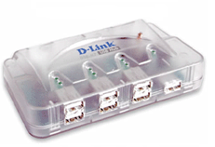

**Figure 3.10. Dlink 7 port HUB**

### SWITCH

On a [network](http://www.computerhope.com/jargon/n/network.htm), a switch is a [hardware](http://www.computerhope.com/jargon/h/hardware.htm) device that [filters](http://www.computerhope.com/jargon/f/filter.htm) and [forwards](http://www.computerhope.com/jargon/b/browser.htm) [packets](http://www.computerhope.com/jargon/p/packet.htm) through the network, but often not capable of much more. The first network device that was added to the Internet was a switch called the IMP, which helped send the first message on October 29, [1969](http://www.computerhope.com/history/1969.htm). A network switch is more advanced than a [hub](http://www.computerhope.com/jargon/h/hub.htm) but not as advanced as a [router](http://www.computerhope.com/jargon/r/router.htm). The picture shows an example of a [NETGEAR](http://www.computerhope.com/comp/netgear.htm) 5 port switch.

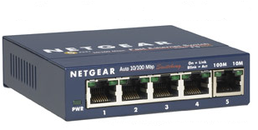

**Figure 3.11. NETGEAR 5 Port Switch**

### ROUTER

A [hardware](http://www.computerhope.com/jargon/h/hardware.htm) device designed to take incoming [packets](http://www.computerhope.com/jargon/p/packet.htm), analyze the packets, moving the packets to another [network](http://www.computerhope.com/jargon/n/network.htm), converting the packets to another network interface, dropping the packets, directing packets to the appropriate locations, and performing any other number of other actions. The picture shows the Linksys BEFSR11 router and is what most home routers resemble.

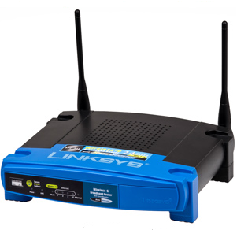

**Figure 3.12. Linksys BEFSR11 Router**

A router has a lot more capabilities than other network devices such as a [hub](http://www.computerhope.com/jargon/h/hub.htm) or a [switch](http://www.computerhope.com/jargon/s/switch.htm) that are only able to perform basic network functions. For example, a hub is often used to transfer data between computers or network devices, but does not analyze or do anything with the data it is transferring. Routers however can analyze the data being sent over a network, change how it is packaged and send it to another network or over a different network. For example, routers are commonly used in home networks to share a single Internet connection with multiple computers.

**Q. What is difference between Hub, Switch and Router?**

## What should I buy for my network, Hub, Switch or Router?

This question really depends on how you plan on using your network. For most users, a wireless network router is our recommendation. A wireless router allows wireless devices (e.g. your [smartphone](http://www.computerhope.com/jargon/s/smartphone.htm), [tablet](http://www.computerhope.com/jargon/t/tablet.htm), [wireless laptop](http://www.computerhope.com/jargon/l/laptop.htm)) to connect to your network and because it is a router it also allows all devices to connect to the Internet.

If cost is a concern and you only want to connect a few computers to each other, a switch is the ideal solution since they are cheaper than a router.

In some situations you may need more than one router or switch. If you are in a big area such as an office you may need a router to connect all the computers to the Internet or other network and then use other routers, switches, or [access points](http://www.computerhope.com/jargon/a/accepoin.htm) to connect other parts of the building to the same network.

**Q. List networking hardware vendors?**

**Ans:**

Cisco, Huawei, Arista Networks, Broadcom, HPE/Aruba, Juniper, VMware, Riverbed, Netscout, Extreme Networks, Dell/EMC

**Q. Connect the devices as follows and ping to show the connectivity**



**Q. In the above network, transfer the data from one computer to another. Have you!**

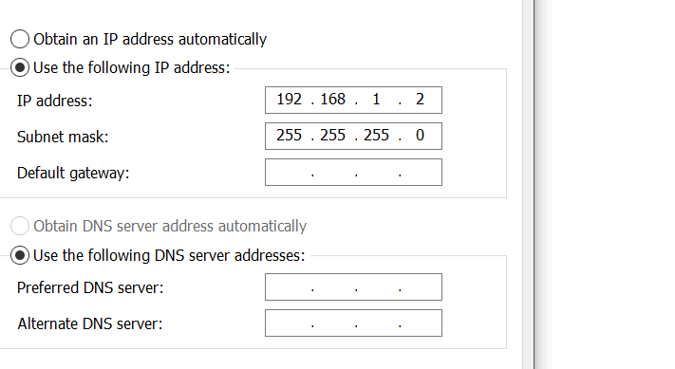

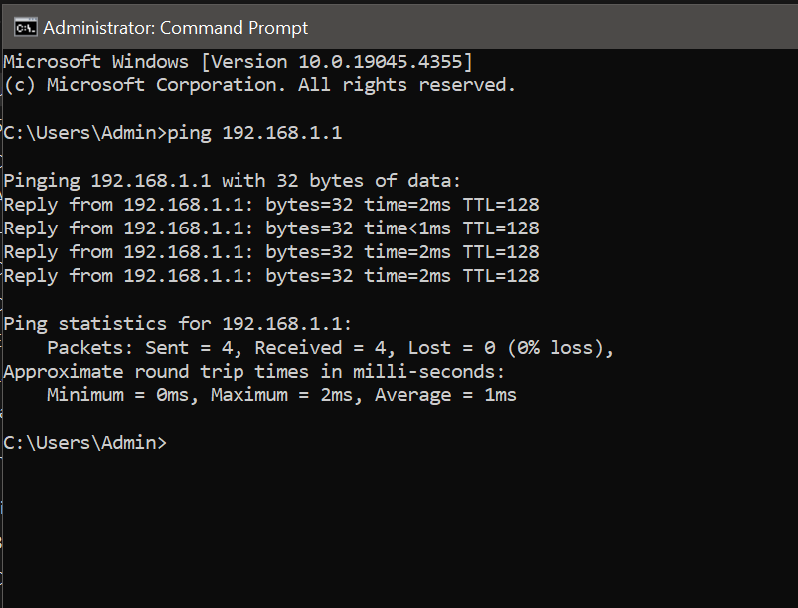

**Q. Connect two computer directly as follows and ping to show the connectivity**



Q. **In the above network, transfer the data from one computer to another. Have you!**

**yes**